722H MOTOR GRADER SPECIFICATIONS

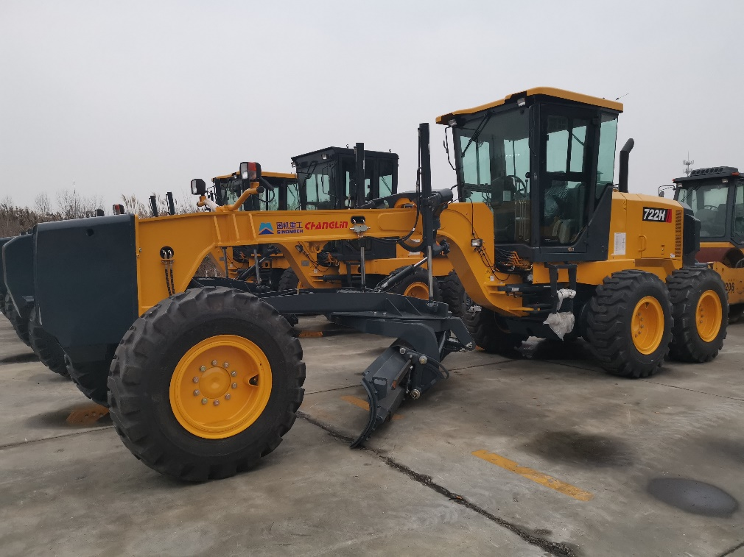
- Equipped withShangChai SC11CB220G2B1 engine
- Sing-handle electro-hydraulic controlled power-shift T/M, 6forward &3reverse shifts makes operation easy and convenient
- Hydraulic lock, auto lock/unlock NO-SPIN differential ensures stability and powerful traction
- Ideal axel load allocation provides excellent stability while cutting hard surface
- Serviceable, efficient hydraulic system enables every part to be fully used
- Box-typed frame and advanced T/M enable it to complete heavy-duty work
- A wide working range is accomplished through flexible blade suspension system and articulated frame

Overall Dimension整机尺寸
1 | Length总长 |  |  |  |  |  |  |  |  |  |  |  |  |  | 9250mm
2 | Width总宽 |  |  |  |  |  |  |  |  |  |  |  |  |  | 2600mm
3 | Height(To the top of the cab)总高（到驾驶室顶部） |  |  |  |  |  |  |  |  |  |  |  |  |  | 3420mm
4 | Wheel base轴距 |  |  |  |  |  |  |  |  |  |  |  |  |  | 6100mm
5 | Tread轮距 |  |  |  |  |  |  |  |  |  |  |  |  |  | 2120(mm)
6 | Min. turning radius 最小转弯半径 |  |  |  |  |  |  |  |  |  |  |  |  |  | 7.4（m）
Main Technical Specification主要技术参数
1 | Operating weight操作重量 |  |  |  |  |  |  |  |  |  |  |  |  | 16100kg
2 | Blade length 刀板长度 |  |  |  |  |  |  |  |  |  |  |  |  | 4320mm
3 | Blade height刀板高度 |  |  |  |  |  |  |  |  |  |  |  |  | 580mm
4 | Shovel Blade thickness 铲刃板厚度 |  |  |  |  |  |  |  |  |  |  |  |  | 16mm
5 | Max. lift above ground 最大提升高度 |  |  |  |  |  |  |  |  |  |  |  |  | 450mm
6 | Max. grading depth 最大切削深度 |  |  |  |  |  |  |  |  |  |  |  |  | 535mm
7 | Max. shoulder reach outside rear tire 铲刀最大侧伸距离 |  |  |  |  |  |  |  |  |  |  |  |  | 2400mm
8 | Traveling speed(Km/h)，6 forward and 3 reverse行驶速度，前六后三
 | (1)forward前进 |  |  |  |  |  |  |  |  | 6.86/11.78/15.51/26.17/32.59/50.86
 | (2) reverse后退 |  |  |  |  |  |  |  |  | 6.86/15.51/32.59
Diesel engine发动机
1 | Model型号 |  |  |  |  | ShangChaiSC11CB220G2B1 engine
2 | Type型式 |  |  |  |  | Direct injection. Turbocharged. Water cooling  直喷、增压、水冷
3 | Rated output额定功率 |  |  |  |  |  | 162 kW
4 | Rated speed额定转速 |  |  |  |  |  | 2200(r/min)
5 | Max. Torque最大扭矩 |  |  |  |  |  | 844(N.m)/(1400r/min)
Transmission case变速箱
1 | Model型号 |  |  |  | 6WG200（ZF）
2 | Type形式 |  |  |  | power shift, single-shift lever, netural-shift lock device  动力换挡、单手柄、中位自锁
3 | Gear shift position档位 |  |  |  | 6 Forward and 3 reverse gears  前六后三
Axle and Tire桥和轮胎
1 |  |  | Max. drawing force 最大牵引力 |  |  |  |  | 82.8KN（f=0.75）
2 |  |  | Size of tire轮胎型号 |  |  |  |  | 17.5-25-14PR(standard) 标配  14.00-24-12PR(optional) 选配
Working Device Hydraulic System工作液压系统
1 |  | Model of oil pump(include steering pump)  油泵型号(包含转向泵) |  |  |  |  |  |  |  |  |  | CBGj1045/1025
2 |  | System pressure系统压力 |  |  |  |  |  |  |  |  |  | 17.5MPa
3 |  | Model of distribution valve多路阀型号 |  |  |  |  |  |  |  |  |  | HUSCO 5000
4 |  | Model of oil motor回转马达型号 |  |  |  |  |  |  |  |  |  | EATON, 604-0663
Steering System转向系统
1 | Type型号 |  |  | Fore Tiredeflexion前轮偏摆式转向
2 | Model of steering gear转向器型号 |  |  |  |  |  |  |  |  |  | BZZ1-E160B+FKA-163022
3 | System pressure系统压力 |  |  |  |  |  |  |  |  |  | 16MPa
Brake System制动系统
1 | Type of traveling brake  行车制动系统型式 |  |  |  |  |  |  |  | Hydraulic and inner-expanding brake  全液压内涨蹄式制动
2 | Model of brake pump制动泵型号 |  |  |  |  |  |  |  | CBGj1016-XF
3 | System pressure系统压力 |  |  |  |  |  |  |  | 10MPa
4 | Type of parking brake停车制动型式 |  |  |  |  |  |  |  | Mechanical and inner-expanding brake  机械式内涨蹄式制动器
Oil Capacity用油量
Fuel(diesel)燃油箱 |  |  |  |  |  |  |  |  |  |  |  |  | 370L
Engine lubricating oil发动机机油 |  |  |  |  |  |  |  |  |  |  |  |  | 27L
Oil for converter and gear box变速箱 |  |  |  |  |  |  |  |  |  |  |  |  | 28L
Oil for hydraulic system液压系统 |  |  |  |  |  |  |  |  |  |  |  |  | 65L
Oil for driving rear axles后桥 |  |  |  |  |  |  |  |  |  |  |  |  | 18L
Tandem box 平衡箱 |  |  |  |  |  |  |  |  |  |  |  |  | 90L

3、722H平地机标准配置表
Standard configuration table for Motor Grader 722H
序号  NO. | 名称  Item | 型号  Model | 厂家  Manufacturer | 产地  Origin
1 | 发动机  Engine | SC11CB220G2B1 | 上柴  ShangChai | 中国  China
2 | 变速箱  Transmission | 6WG200 | ZF | 中国  China
3 | 驱动桥  Axle | 220H.8 | 常林  Changlin | 中国  China
4 | 轮胎  Tire | 17.5-25-14PR | 三角轮胎  Triangle | 中国  China
5 | 工作液压油泵:  Working Pump | CBGj1045/1025 | 济南  JiNan | 中国  China
6 | 转向装置  Steering System | BZZ1-E160B/ FKA-163022 | 镇江液压件厂  ZhenJiang | 中国  China
7 | 回转马达  Rotary motor | 604-0663 | 伊顿  EATON | 美国  USA
8 | 差速器:  Differential | NO spin | 伊顿  EATON | 美国  USA
9 | 多路阀  Valve | 5000 | HUSCO | 美国  USA
10 | 液压锁（提升）  Hydraulic lock(lift) | WBCDELU-03-B | LUEN | 意大利  Italy
11 | 空调（选配）  Air conditioner |  | 豫新  YUXIN | 中国  China

